International Taekwon-Do Federation (I.T.F)

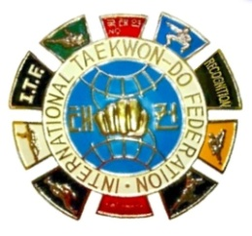
국 제 태 권 도 련 맹
Draugasse 3, 1210 Vienna, AUSTRIA
Tel. (+43-1) 2928467 Fax (+43-1) 292846789
E-Mail: secretary-gen@itfhq.org director-af@itfhq.org
Website: www.itf-tkd.org

APPLICATION FOR ITF COMMENDATION

Passport size digital photograph
Name: Mr. / Ms.
First name (1 only) Family name

Nationality: Birth place:

Date of birth: Profession:

Address:

Qualifications:

Education (School, Tertiary etc.):

Dan Cert. No. plaque No. Applied for:

Reason for recommendation:

NGB Representative Name: Signature:

Name of NGB:
(NGB Stamp)
Place (Town, Country): Date:

Prof Ri Yong Son, ITF President Signature:

Date:
(ITF Stamp)

